**Unix/Linux Basic Commands**

1. **uname -> gives username 🡪 Linux**
2. **uname –r -> -r is uded for recursion i.e for mor details**
3. **uname –a -> for all detailed decription 🡪**Linux server-1.localdomain 3.10.0-514.16.1.el7.x86_64 #1 SMP Wed Apr 12 15:04:24 UTC 2017 x86_64 x86_64 x86_64 GNU/Linux

**Note 1 :** If we have forward slash with hash sign (**/#**) then we are in user directory

**Note**  2 : If we curly hyphen with hash (**~#**) then we are in root directory

**File Handling :**

1. **touch 🡪** used to create a file 🡪touch abc 🡪 a newfile named abc is creted.
2. **touch xyz.txt** -> a text file will be created
3. **rm xyz**.txt 🡪 to delete a file

**How to create a directory or folder:**

1. **mkdir bharat ->** make a folder named bharat
2. **rmdir bharat ->** to delete a folder named bharat

**man ls :** manual list of all the linux command

**q :** to quit and return back to previous one directory

**How to copy one file from one location to other location : cp test /home/ 🡪** test file is now copied to home directory

**Permission related command :**

**There are three types of permission are in linux:**

1. **Admin**
2. **Group**
3. **Public**

**How to check the permission level about any file ?**

**ls –l test : ->** We are checking what type of permission is defined for test file **--🡪** -**rwxr-xr-x.**

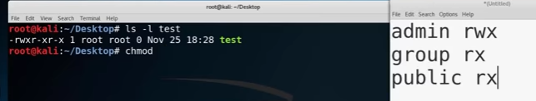

**We can change the permission using number :**

**1 ->execute**

**2 ->write**

**4 -> read**

and **chmod** command is used to change permission for all level**.**

**Ex: If we want to give permission for all three levels as**

**Admin : rwx ----🡪4 +2+1 =7**

**Group : rw ----🡪 4+2 =6**

**Public : r ---🡪 4**

Then our command will be :

**chmod 764 test**

after that if we test the permission using **ls –l test**

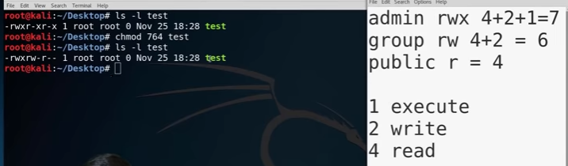

**Account related commands:**

**$ and # 🡪** whenever we open a terminal and after our account if you see the $ sign it indicates that you are logged in as a normal user and # indicates that you are logged in as a root user.

$ -🡪 Normal user

# 🡪 Root user

**su -> if we enter just after entering the su command it will mount us directly to password**

**su [login name]🡪 super user command -🡪** after providing user name it will ask for password after providing proper password it will take you into the account

eg: su root --🡪 to mount to root user and will ask it password..

**whoami ->** To check you are a root user or which user you are logged in

**passwd ->** To change the password of logged in

**eg: passwd root 🡪** it will ask for new password for root user

**id ->** to show your user id 🡪 if value is 0 🡺 it means it is a root user.

**File System related commands :**

**cd 🡪** change directory

**cd ~ 🡪** Moved directly to root directory

**pwd ->** Current/Print working directory

**locate filename : 🡪** It will search the file in the entire computer and gives the location

**ls :** list command 🡪 which lists all the files and folders that are there in thedirectory. Similar to the dir command in windows

**ls –l :** will show the permission associated with each file

**ls –a :** will show hidden file that are there in that particular directory/folder.

Hidden files are always started with .

**cp source destination :** copy a particular file from the source to a particular destination

**mkdir** -> make adirectory

**rm** 🡪 Delete a directory

**gedit filename** 🡪 Open a text editor to edit that particular file

**cat filename** 🡪 show the content of the file and is open to the terminal itself

**less filename** 🡪when a file is very large and can’t fit the entire stream. By using less command we can go through the file one line at a time ie line by line

**|(Piping) 🡪 whenever we give a command and give a pipe the result of that particular command will go through whtever is comes after the pipe.**